Assignment A.8 - Milligan Chapter 7 Manually Graded

Student Name: | < Replace this text with your name >

Assignment A.8- Milligan Chapter 7

Week 2- Milligan Chapter 7

Welcome to your hands-on activity! This assignment invites you to work with Tableau using a mix of generated and real-world data. You will:
- Download the attached spreadsheet and upload those data sets into Tableau. If you need help loading your data sources, refer to Assignment A.2 for help.
- Go through this document and use Tableau to answer all the questions listed below. Where applicable, paste screenshots into the template below.
- Remember, you can always reach out for help to your instructor if needed.
- Your faculty member will be grading this manually.
- If you need to adjust the size of your visualizations to match the options in the questions, use the “Format”->”Cell size” options. For example, “Ctrl+Shift+B” on a Windows computer will make the visualization bigger and “Ctrl+Up” will make it taller.

This assignment has four datasets. All of them show the high/low temperatures (in Celsius) for each day in July 2021 at a particular location.
- Assignment A.8 Data Set A shows data for Keflavík International Airport, Iceland.
- Assignment A.8 Data Set B shows data for Noi Bai International Airport, Hanoi, Vietnam.
- Assignment A.8 Data Sets C and D are the same as A and B, but with random values missing.

For problems 1–3, a visualization with Data Set A is given. The assignment is to re-create the visualization with Data Set B. For problems 4–6, use Data Sets C and D.

Throughout this assignment, you will be modifying different options on a line graph. We are going to start off by making a line graph of the temperature using Data Set A. Make sure you turn off aggregation (Analysis menu). As you work through the problems, you can duplicate your worksheets and make changes, so you have copies of each problem. Your basic graph should look something like the following. Your columns should be day with High and Low in your rows:

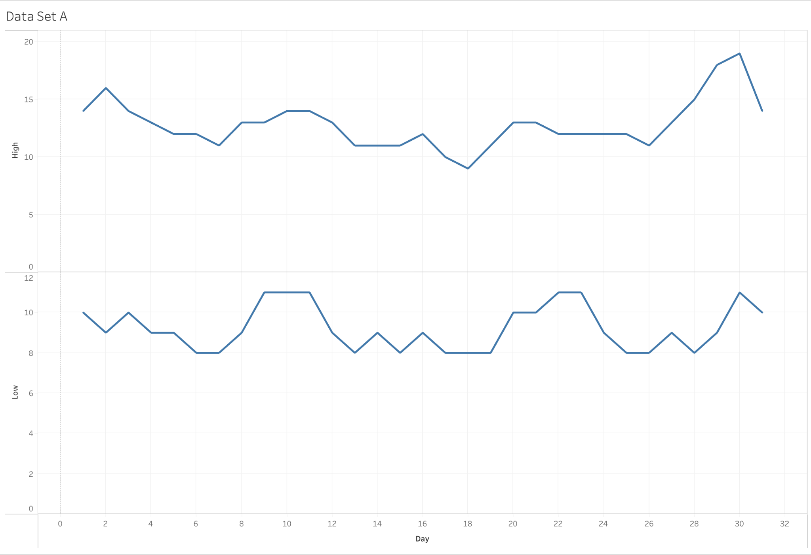

Problem 1 – Text formatting

Change the title font to “Arial”. We have done this below for Data Set A,
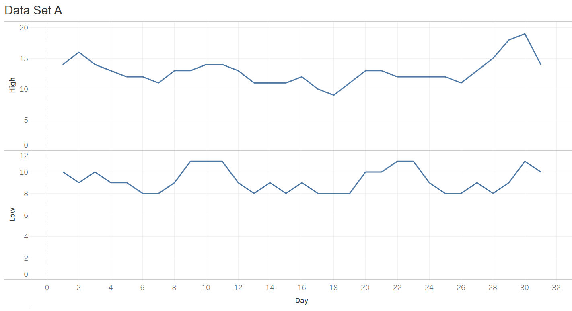 so you can see what Arial font looks like. Make the graph using Data Set B, and then paste it below.

Data Set B Output

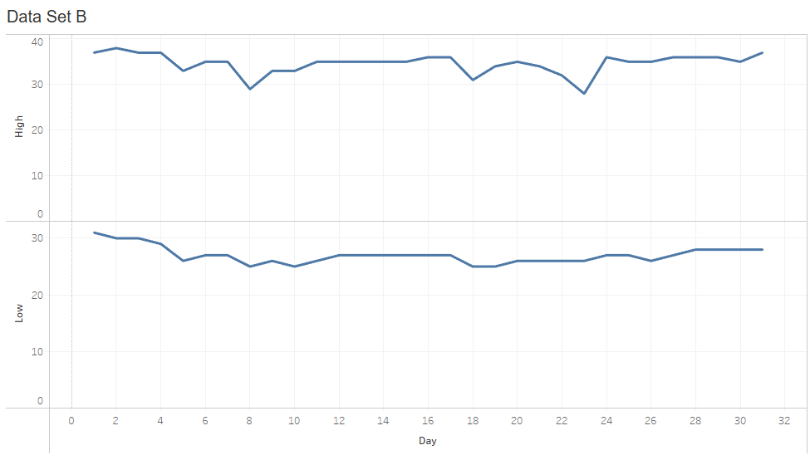

Problem 2 – Number formatting

Change the temperature numbers to decimals. If you need help, refer to page 204 of Milligan Chapter 7. Below is a sample using Data Set A.

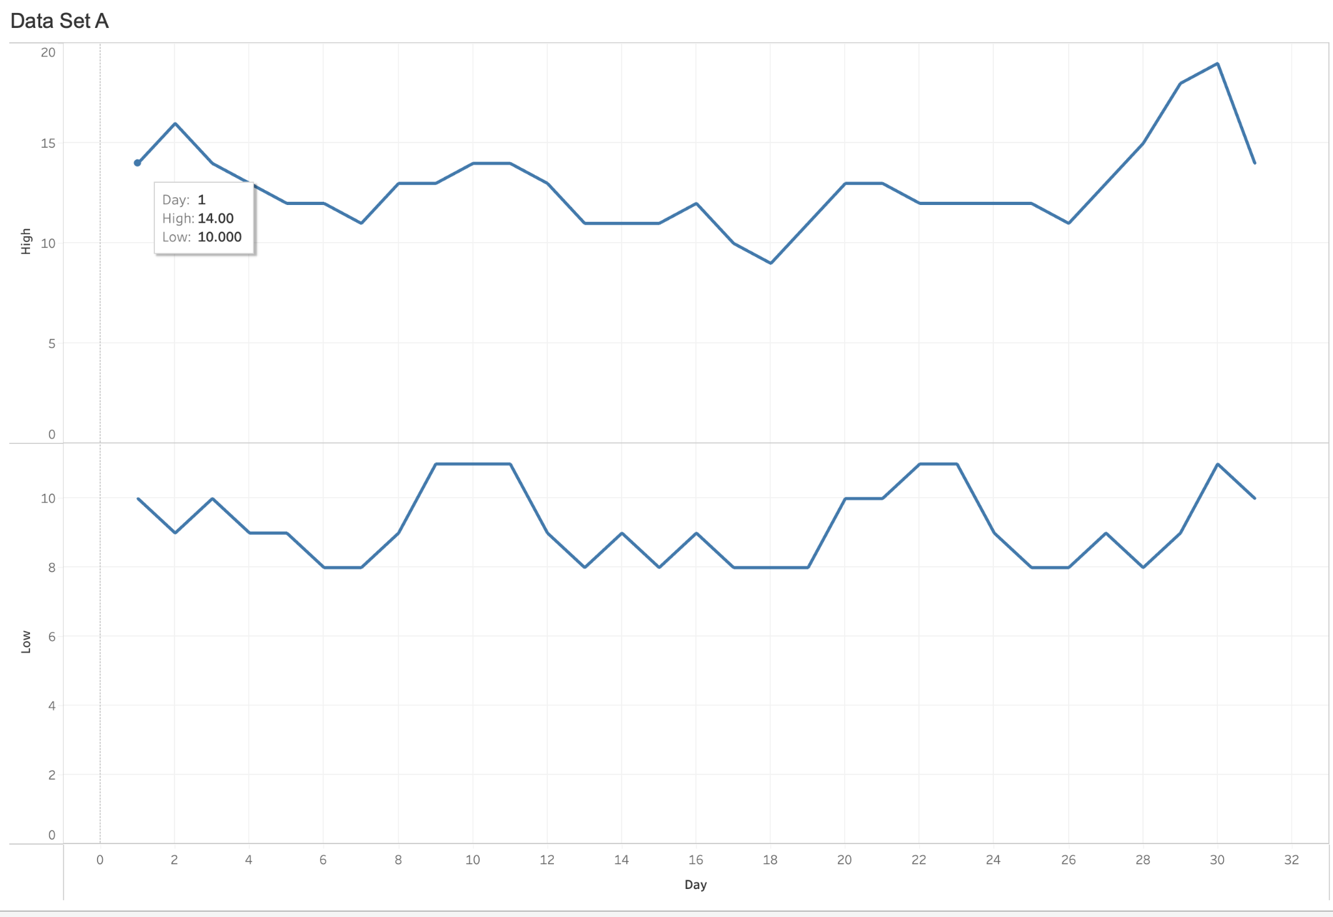

Make the graph using Data Set B, and then paste it below.

Data Set B Output

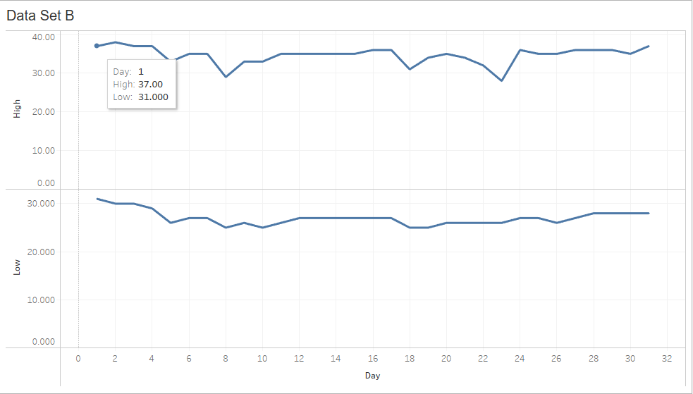

Problem 3 – Date formatting

Change the date numbers to dates (in July 2021). This will require creating a calculated field. Here’s how we did this in a little Tutorial for Data Set A:

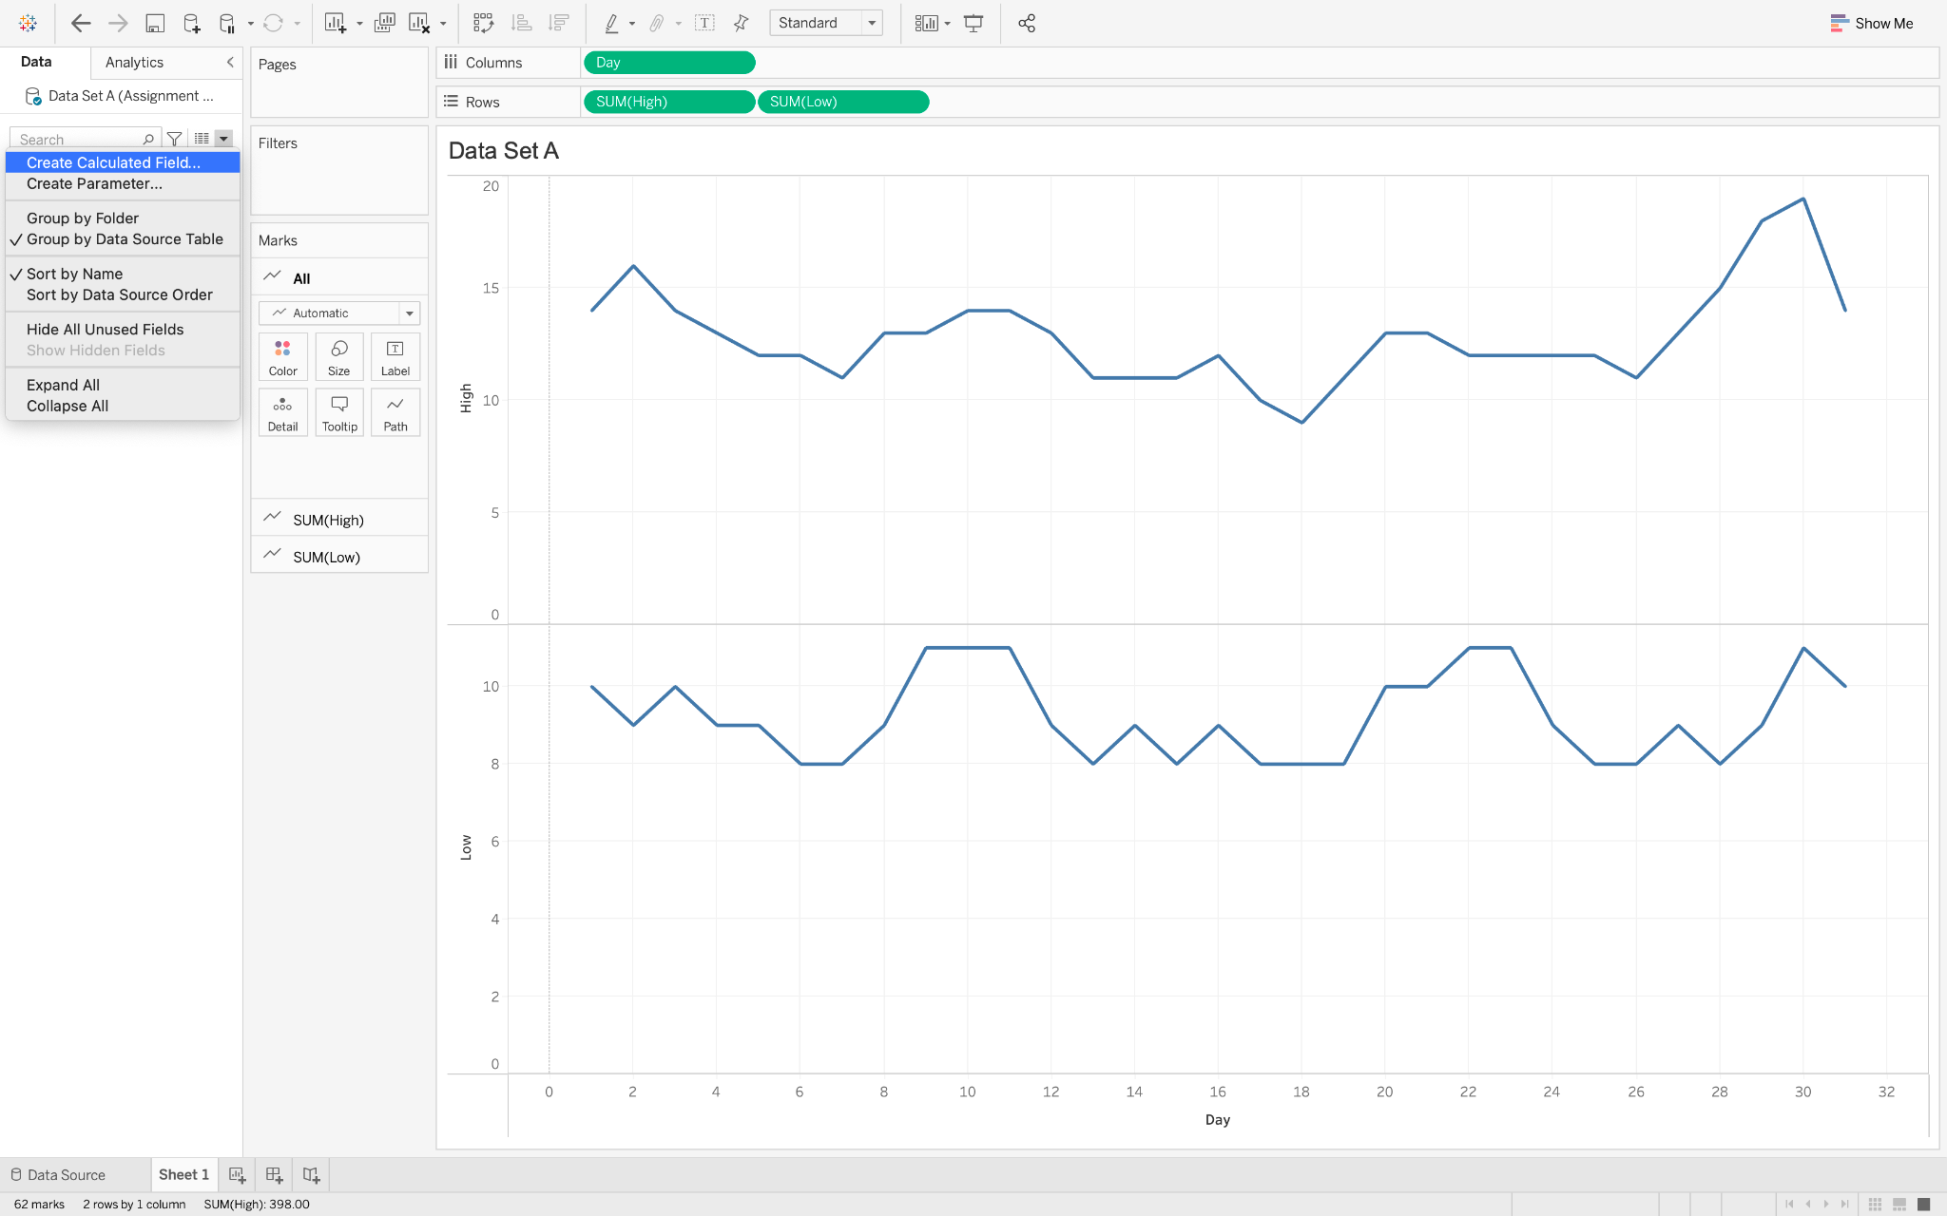

Select the “Create Calculated Field” button.

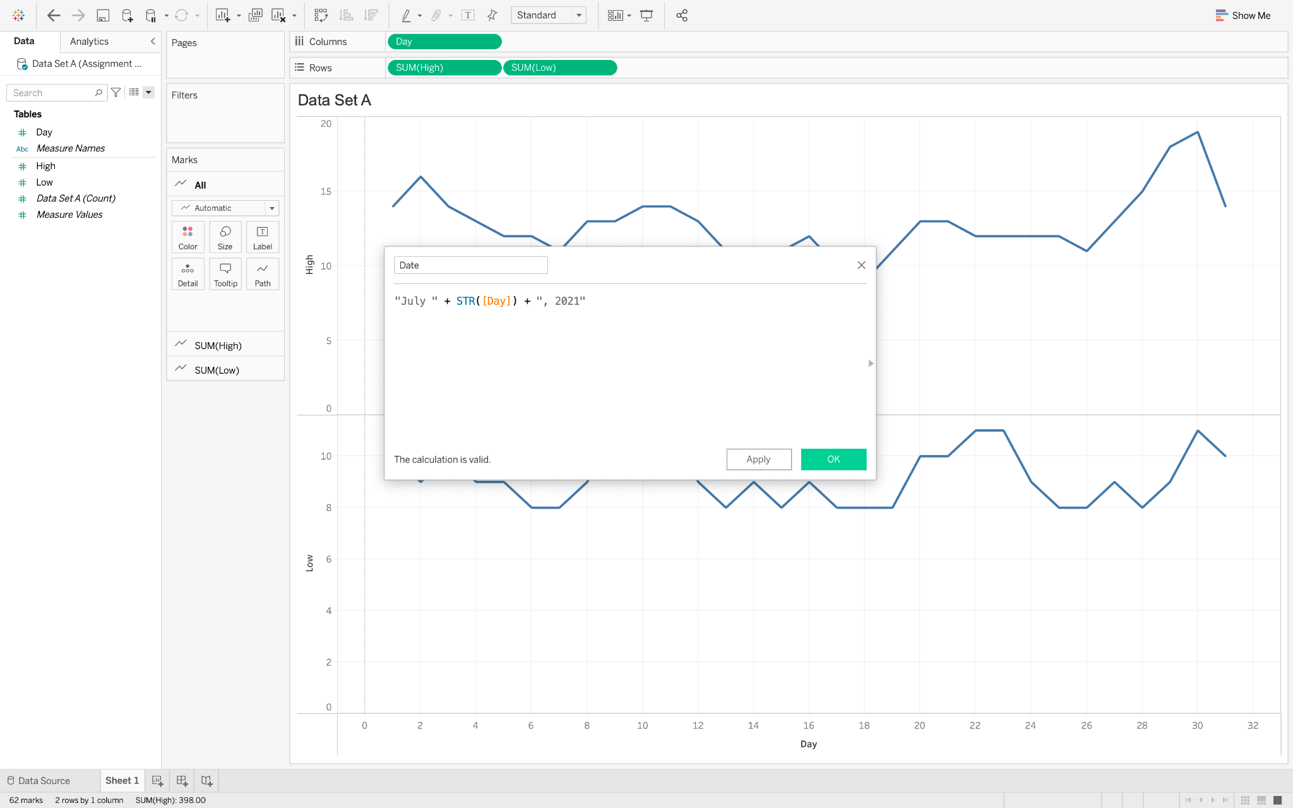

Input this text into the dialog box.

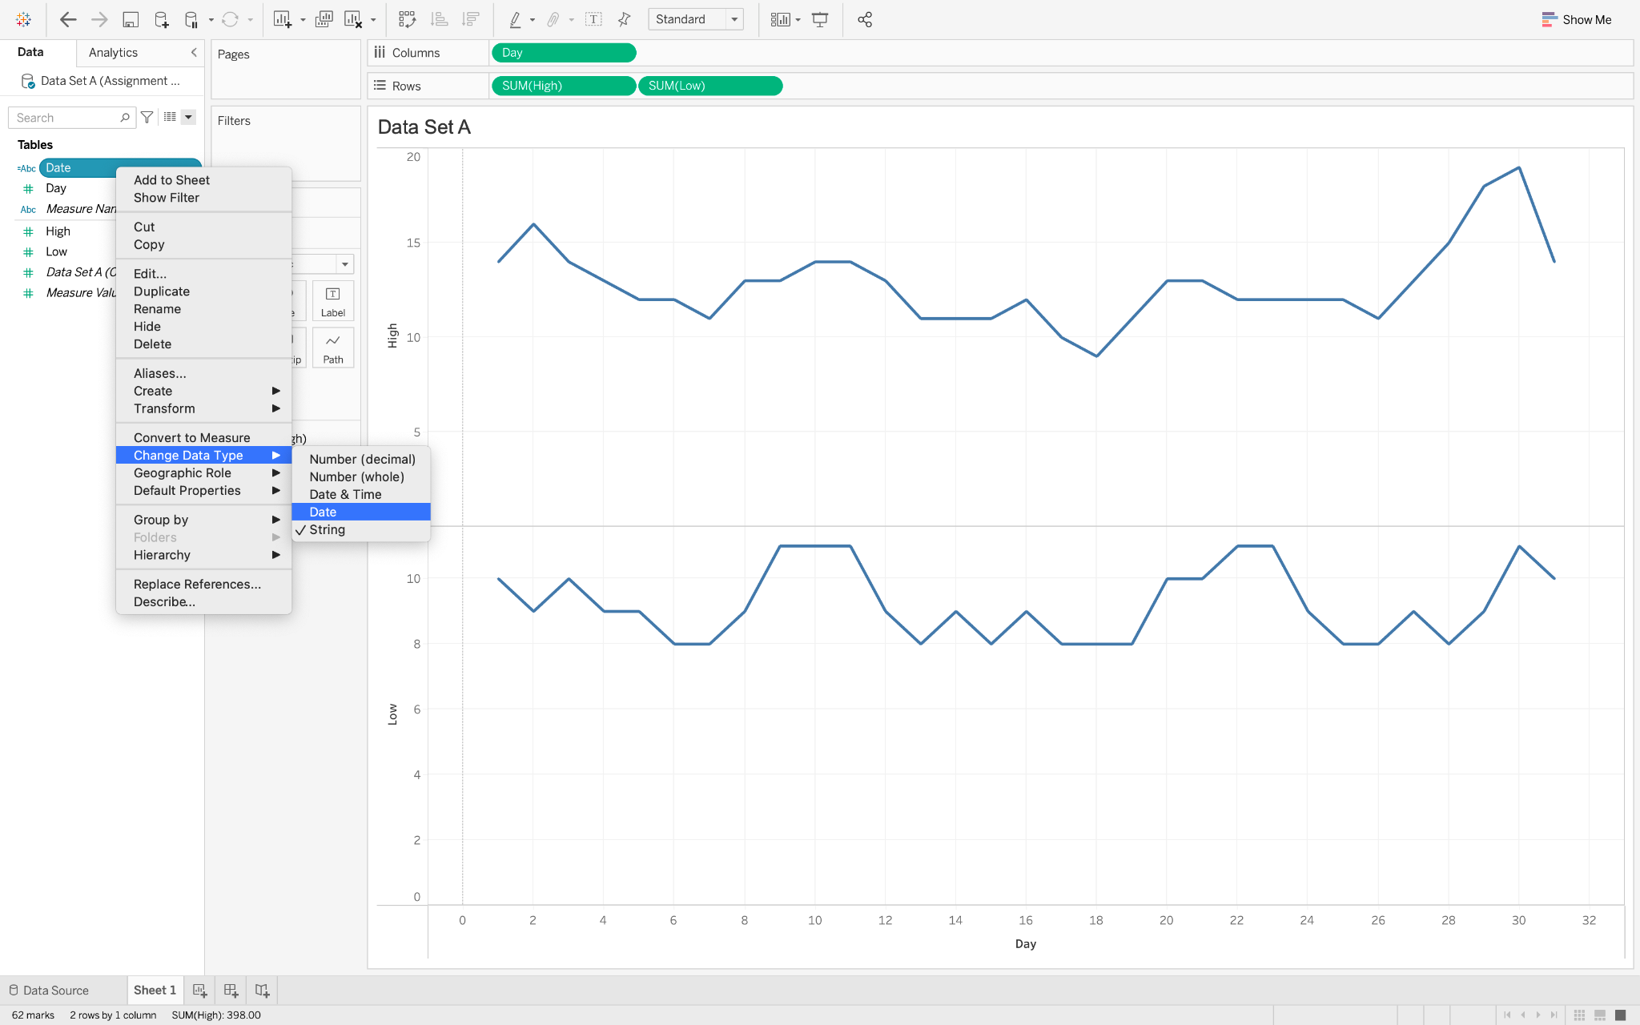

Change the data type to “Date”.

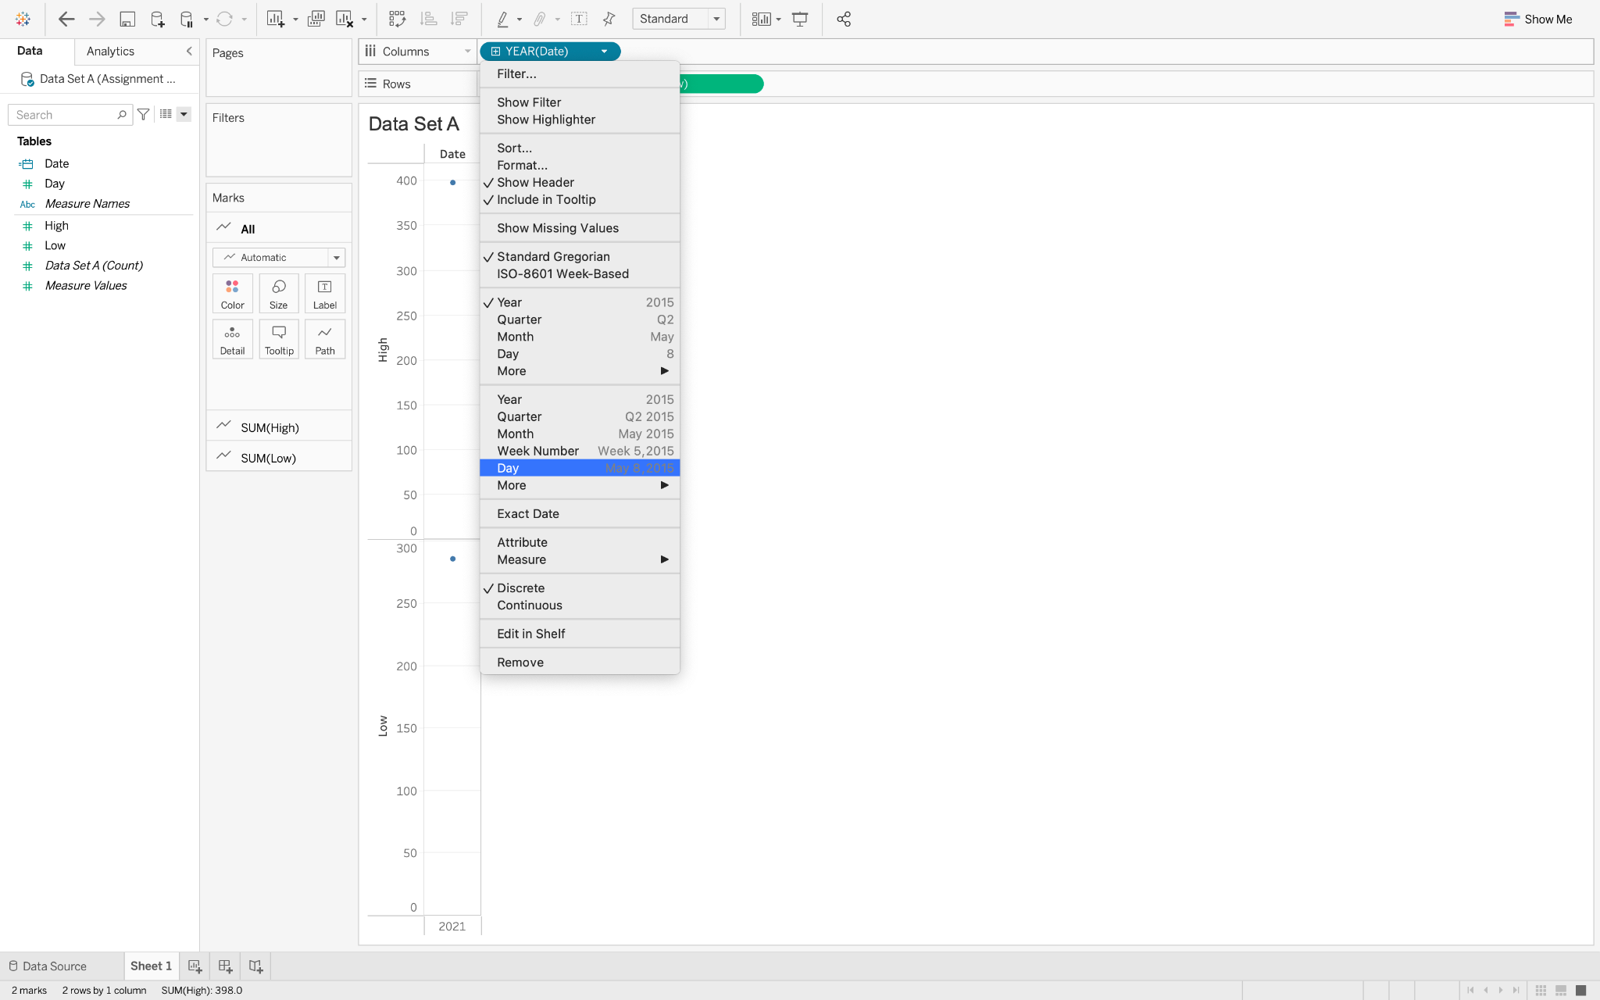

Add the field to the Columns shelf. Remove the “Day” field that was previously in the columns area.

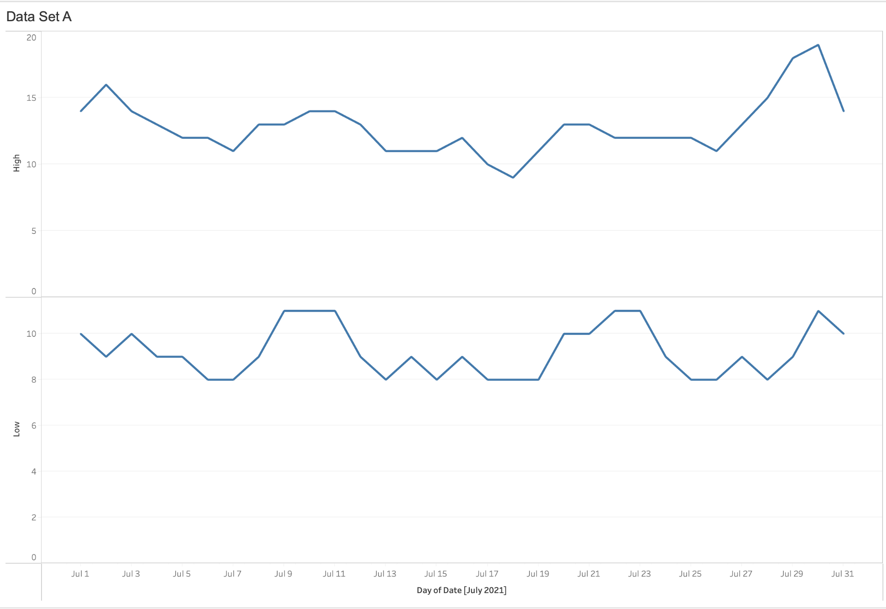

Make the graph using Data Set B, and then paste it below.

Data Set B Output
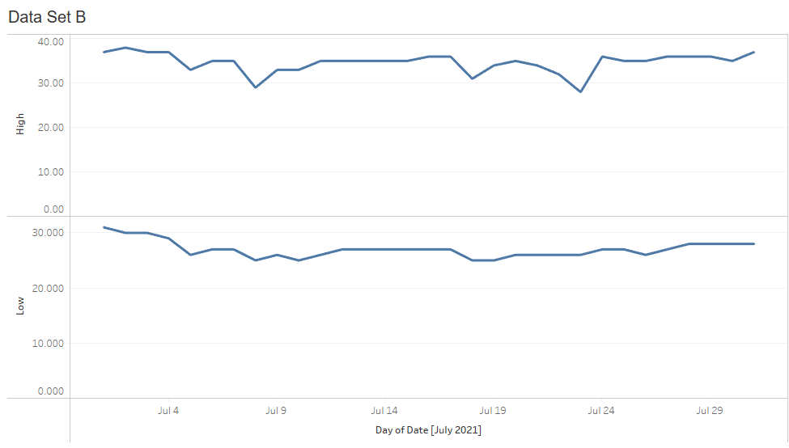

Problem 4 – NULL values

Edit the graph so that the line does not break in two when passing through NULL values. Follow the steps in the tutorial to see how we did it for Data Set C:

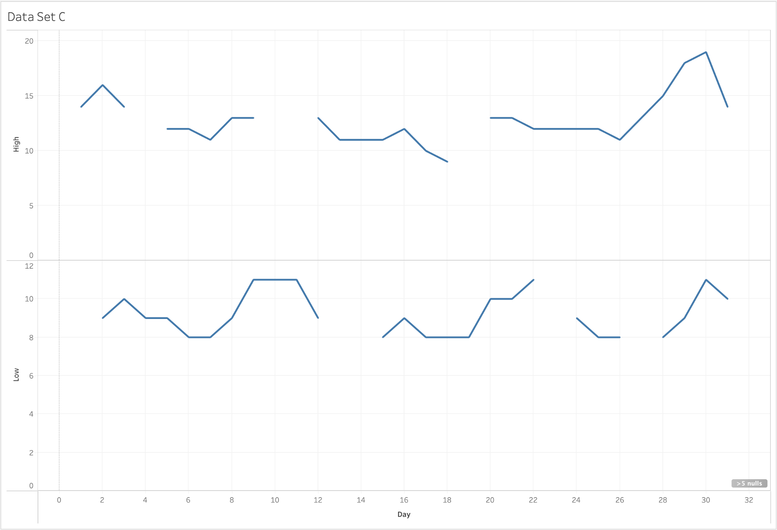

Start with this graph.

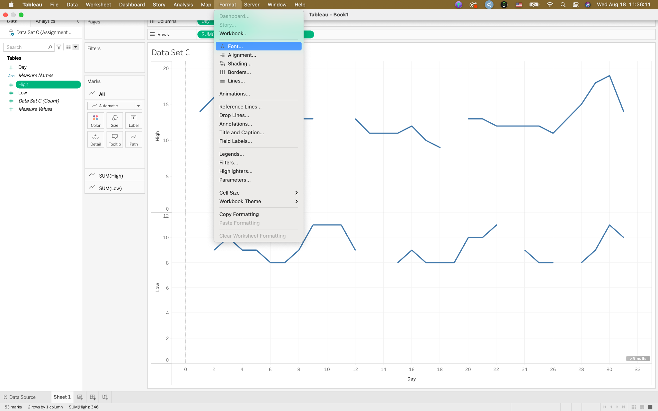

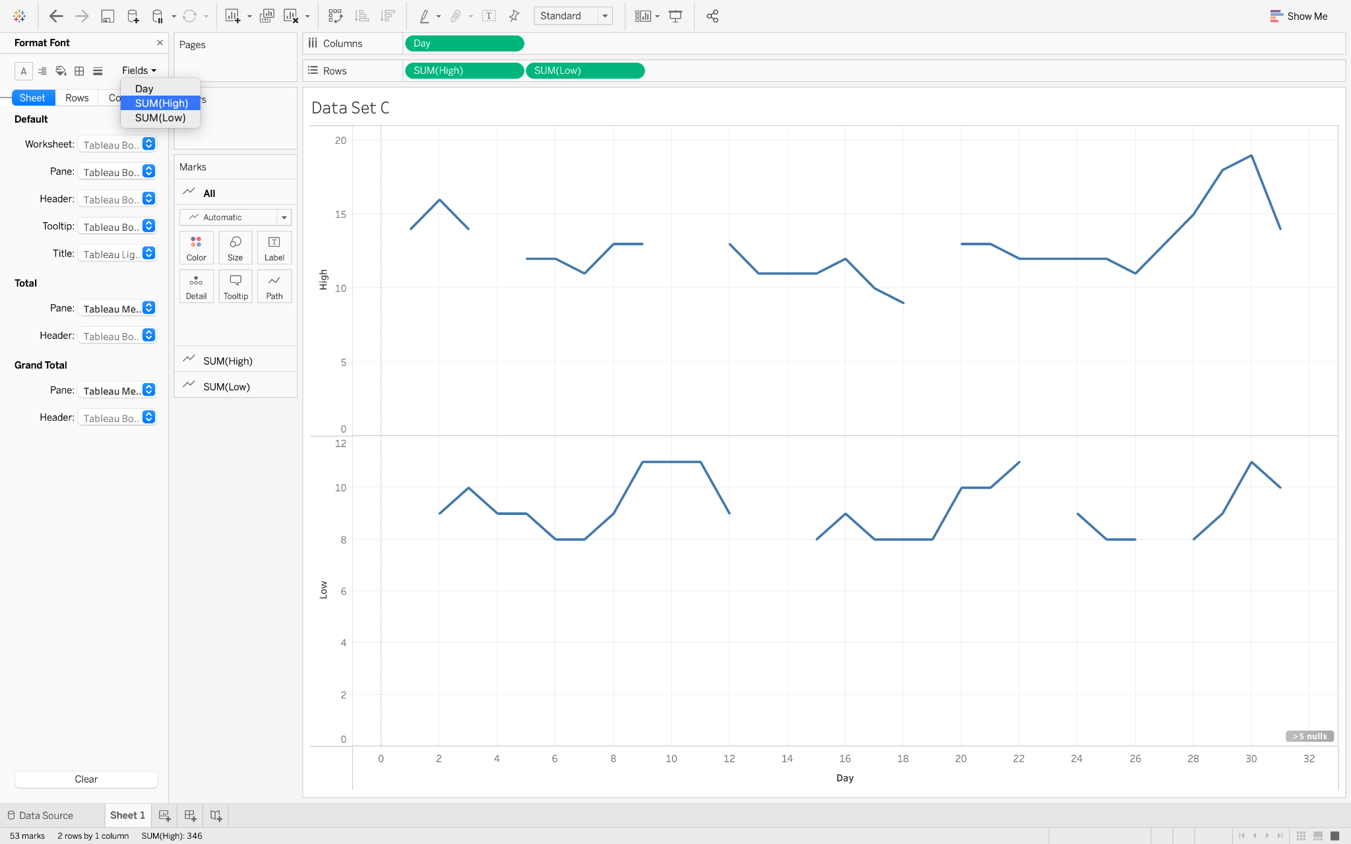
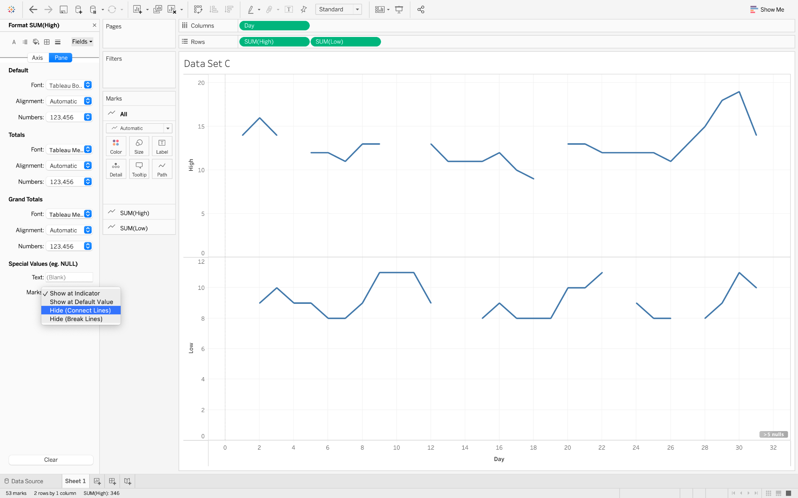

Do the same thing for the other field.

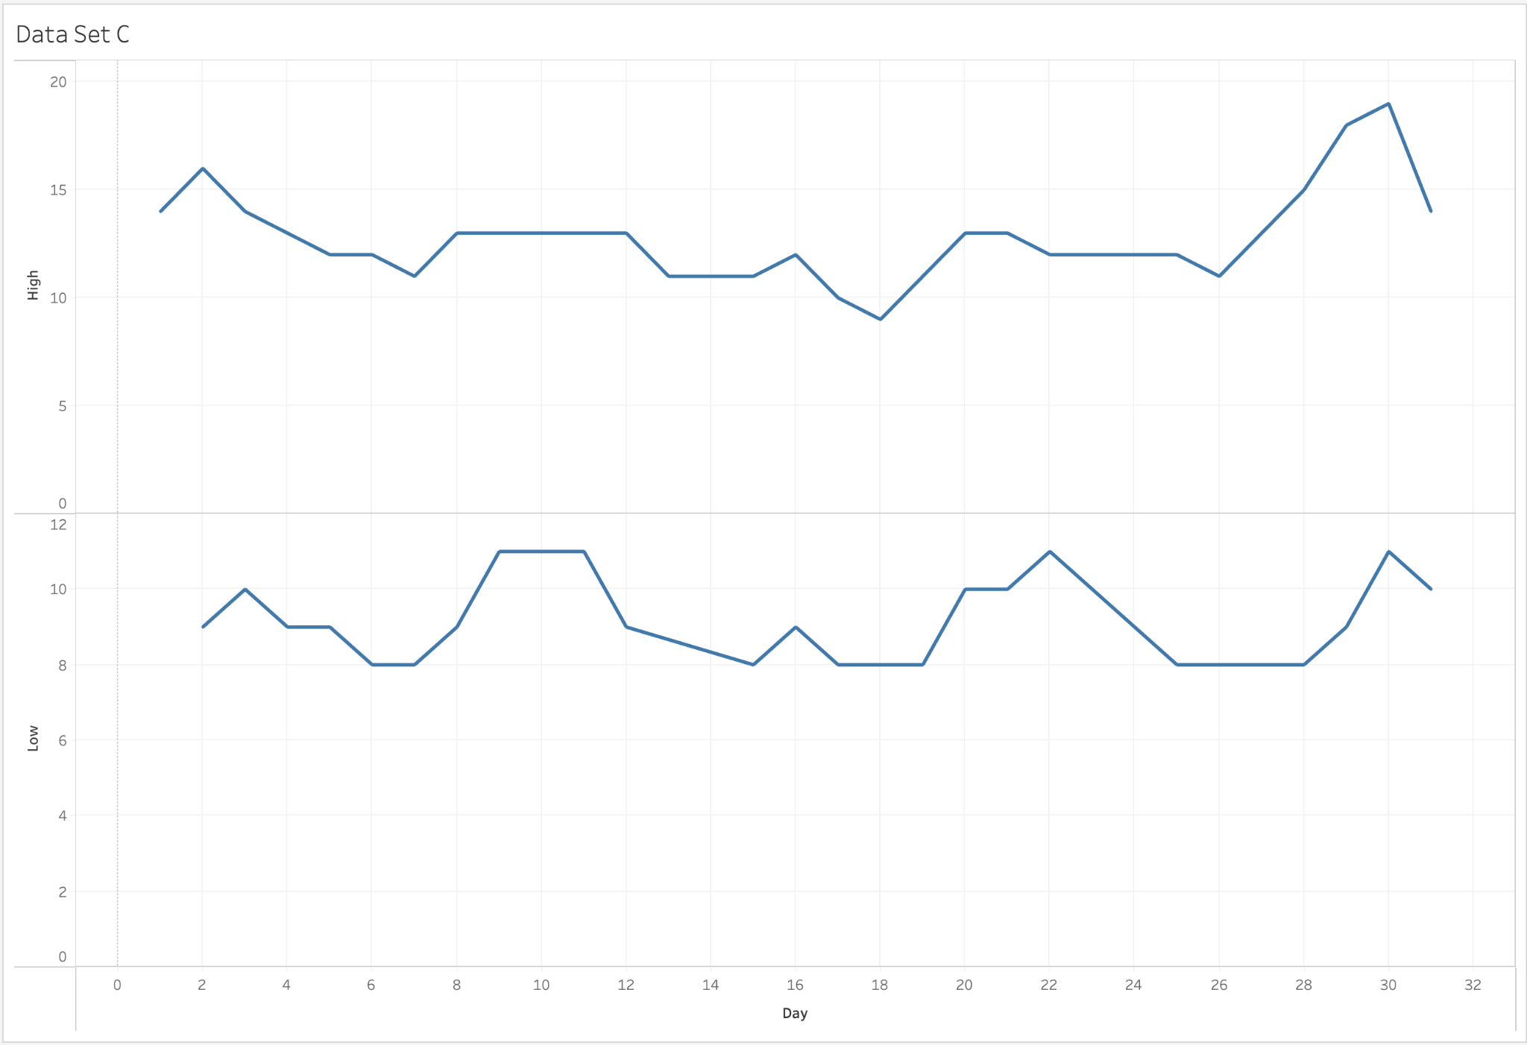

Make the graph using Data Set D, and then paste it below.

Data Set D Output

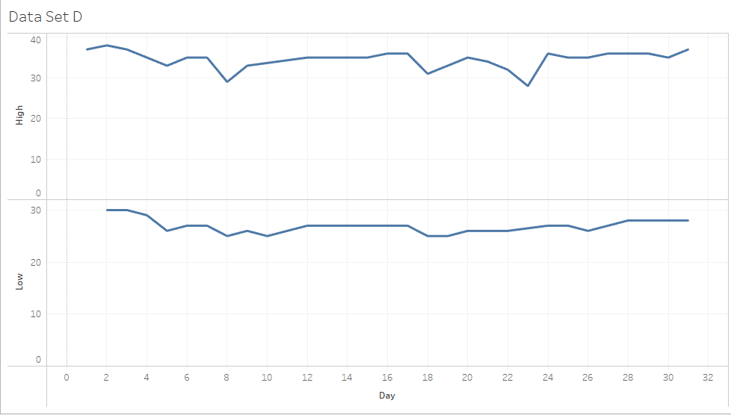

Problem 5 – Annotations

Create a Mark annotation for Day 6, a Point annotation for Day 18, and an Area annotation for Days 25–30. Here’s what it looks like for Data Set C. Now, using Data Set D, create similar annotations appropriate to this dataset.

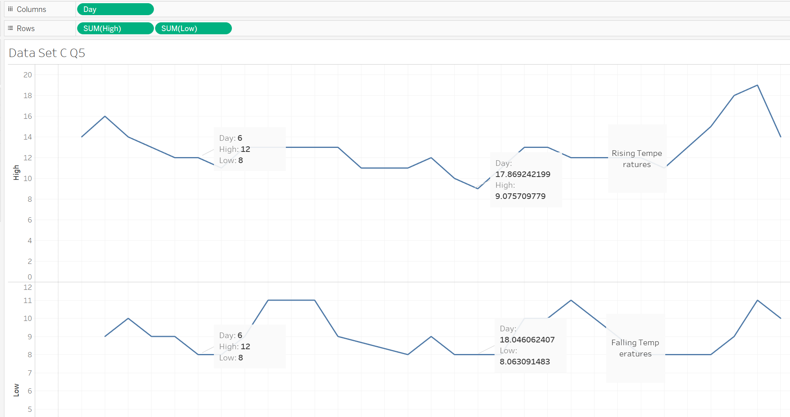

Make the annotations on the graph using Data Set D, and then paste it below.

Data Set D Output

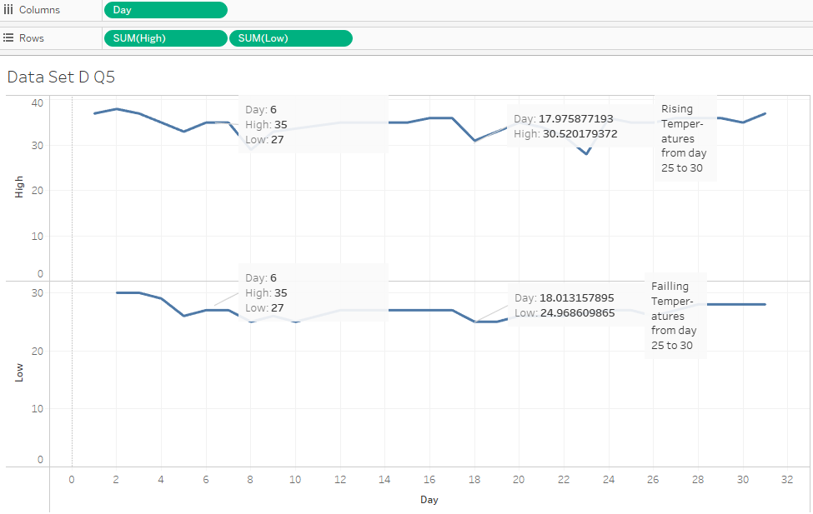
Problem 6 – Tooltip visualizations

We will create a bar chart for the average high/low temperatures of Data Set A (you will make it using Data Set C) and use it as an annotation in the main chart. This is pretty cool. Here’s how we did it.
Create a bar chart using the Averages of the Measure Values (dimension and measure). Remove the CNT measure values and change the SUMs to AVG. Click on the “Swap Rows and Columns” button 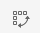to move Measure Values to Column and Measure Names to Rows.

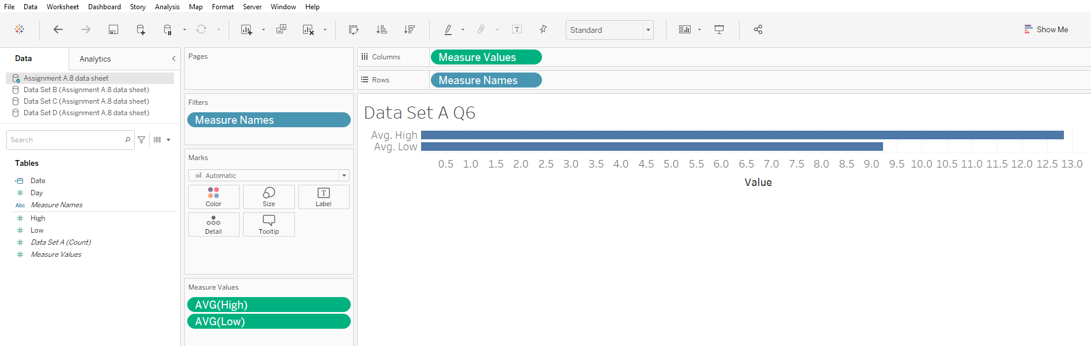

Now, go back to the line chart of highs and lows that we have been working on and click on Worksheet, Tooltip.
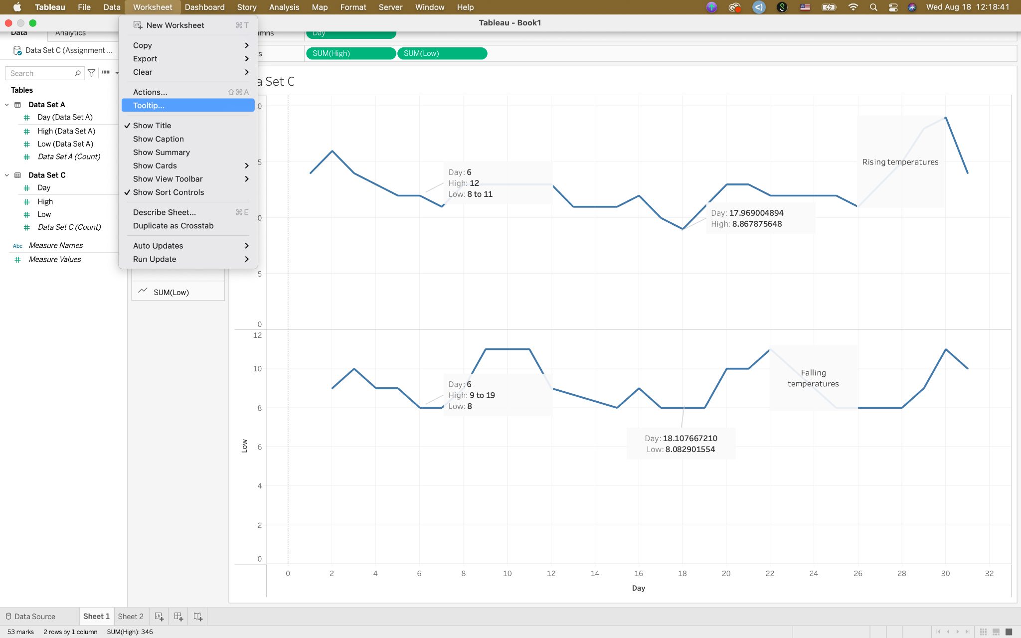
When the “Edit Tooltip” window opens, click on the Insert dropdown box and find the bar chart you just created.
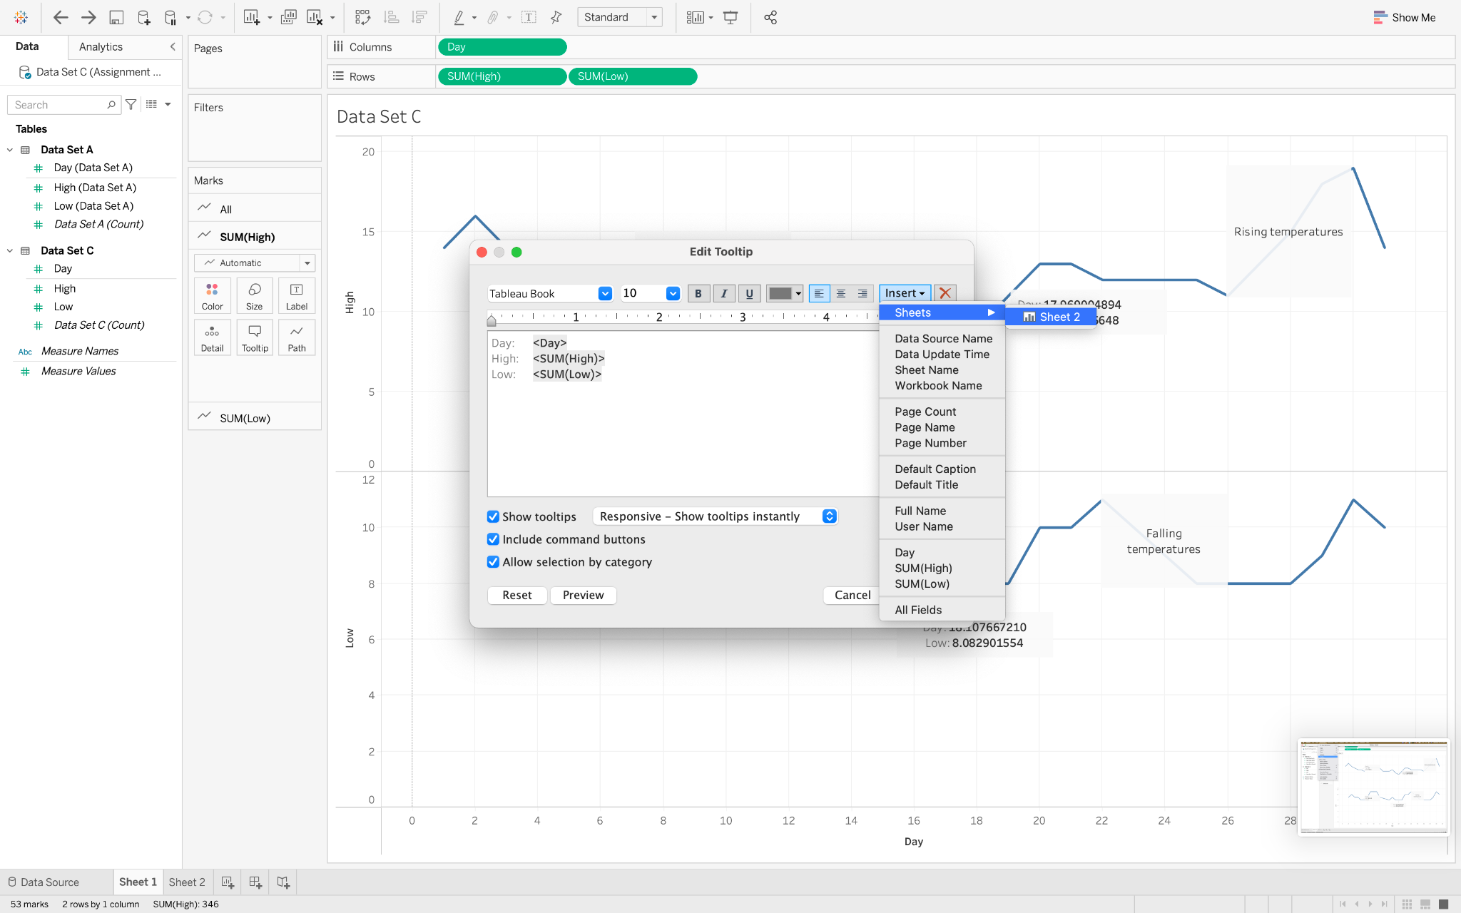

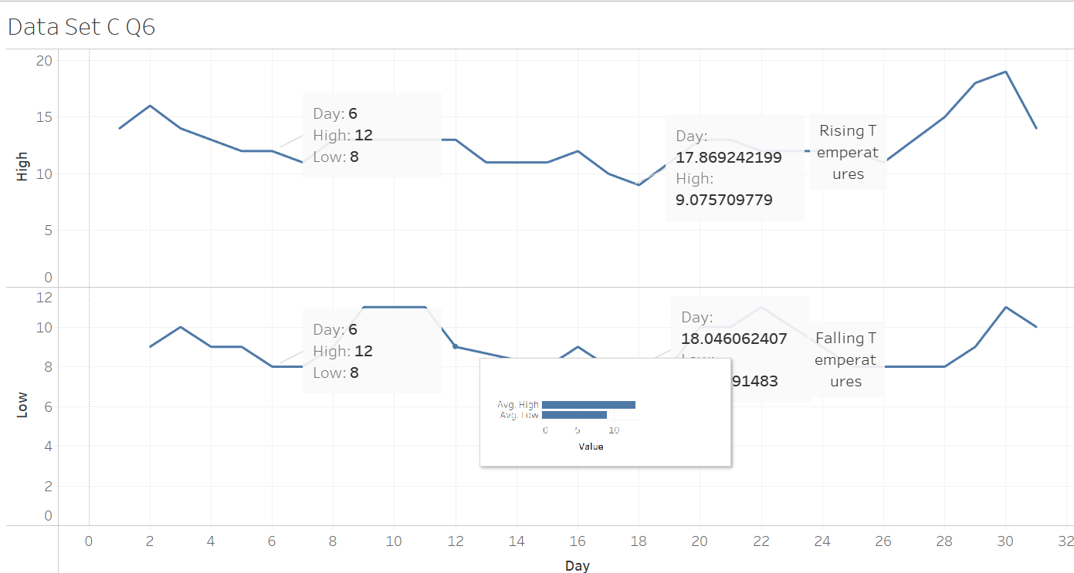

Because the tooltip works when you hover over the graph, you have to change the Snipping Tool to allow you to capture it. In Snipping Tool, change the Delay to 4 seconds, then click on “New” and hover the mouse over the line. Now you should drag the crosshairs to make an area to capture.

Now, you will create this tooltip using Data Set B applied to Data Set D. Paste your screenshot below.
Data Set D Output



